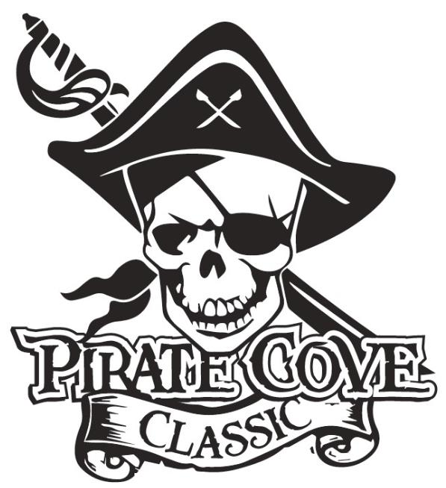
Corporate Sponsorship Levels

Swabbie $300
- Name in program as a sponsor
- Name on website

Mate $500
- Name in program as a sponsor
- Name on website
- Name listed on banner during event

Master Gunner $1000
- Name in program as a sponsor
- ¼ page ad in the program
- Name and logo on website
- Name and logo on banner

Quarter Master $1500
- Name in program as sponsor
- ¼ page ad in the program
- Name and logo on website
- Name and logo on banner
- Announcement on sponsorship during event awards

The Captain $2000
- Name in program as sponsor
- ½ page ad in the program
- Name and logo on website
- Name and logo on your own “Captain” Level Sponsor Banner
- Announcement on sponsorship throughout the event
- Sign on for future “Captain” levels for $1800 for upcoming years

NOTE: BANNER SIZES WILL BE NO LESS THAN 2’ X 2’ AND PLACED IN THE STADIUM DURING THE EVENT. SIZES WILL VARY DEPENDING ON NUMBER OF SPONSORS.
Porter Ridge Band Boosters is a recognized as a 501(c)(3) tax-exempt organization and all contributions are tax deductible.

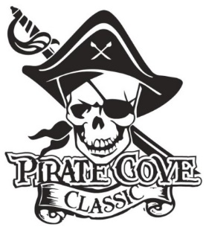
Corporate Sponsor
Order Form

$10

Name: _______________________________________________________________________

Address: _____________________________________________________________________

Phone: _____________________________ E-mail: __________________________________

Deadline for submission is October 10, 2021

Sponsorship Level | Cost | Total
Swabbie | $300
Mate | $500
Master Gunner | $1000
Quarter Master | $1500
The Captain | $2000

Payment can be made online Porterridgeband.org. Under the menu, select Pirate Cove Classic.
Please e-mail artwork and the completed sponsor form to pccsponsors.ads@gmail.com
Preferred file formats: hi-res JPEG, PDF files.

Other ways to pay:
Enclose completed form, payment, checks made out to PRBB, and place in the lock box in the band room office or mail to:
Porter Ridge Band Boosters/PCC
P. O. Box 1624
Indian Trial, NC 28079

Questions? Please contact us at pccsponsors.ads@gmail.com

