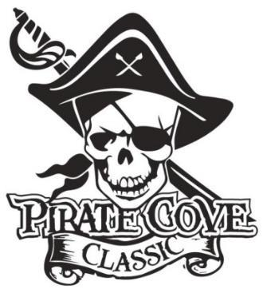
Class of 2024
Senior Ads
Deadline for submission is October 6, 2023

Parent’s Name: _______________________________________________________________

Your Senior’s Name: __________________________________________________________

Address: _____________________________________________________________________

Phone: __________________________ E-mail: _____________________________________

QUANTITY AD SIZE AD DIMENSIONS COST TOTAL
 | Quarter Page | 4.25” x 5.50” Portrait | $45
 | Half Page | 8.5” x 5.50” Landscape | $75
 | Full Page | 8.5” x 11” Portrait | $135

Senior Ads are to recognize your senior for all their hard work over the last four years. They will be printed in color and included in the PCC program. Your ad may include any photo of your senior (baby photo, band photo, special occasion, etc.)

Your ad should be print ready and photos must be no less than 300dpi. If you need the ad to be created for you, please include a $10 fee. Preferred file formats: PDF, Word

Please e-mail completed message form to pccseniorads@gmail.com or place everything in an envelope and place in the lock box in the band room office.

Payment can be made online www.Porterridgeband.org. Under the menu, select Pirate Cove Classic.

Other ways to pay:
Enclose completed form, payment, checks made out to PRBB, and place in the lock box in
the band room office or mail to:
Porter Ridge Band Boosters/PCC
P. O. Box 1624
Indian Trial, NC 28079

Questions? Please contact us at pccseniorads@gmail.com. Thank you for your support!

