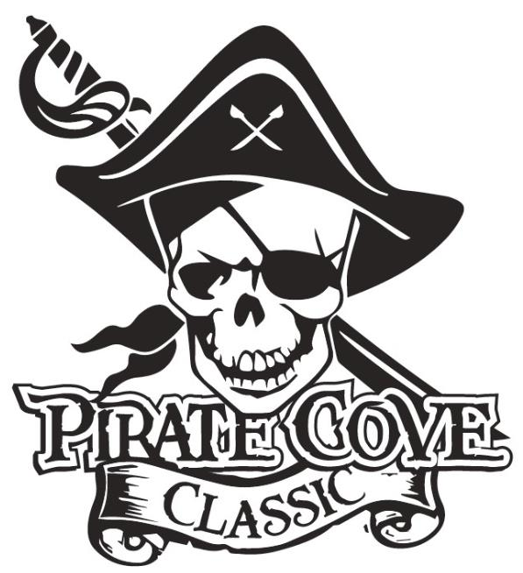
Total Trophies available for sponsorship | Place  Trophy Sponsorship  Deadline for submission is October 20, 2023  All Trophy Sponsorships will be announced during the awards ceremony.  $10 | Total trophies you wish to sponsor* | Cost Per Trophy | Total $
42 | 1st Place |  | $45
42 | 2nd Place |  | $35
42 | 3rd Place |  | $25
Total Trophies available for sponsorship | Place | Total trophies you wish to sponsor* | Cost Per Trophy | Total $
1 Overall | Best Pit Crew | 1 | $150
1 Overall | Spirit Award | 1 | $200
3 Overall | Top Scoring |  | $150
Total Trophies available for sponsorship | Place | Total trophies you wish to sponsor* | Cost Per Trophy | Total $
1 | 1A/2A/3A Grand Champion | 1 | $250
1 | 4A/5A/6A Grand Champion | 1 | $250
*If your desired trophy is unavailable, we will assign a trophy similar in value.

Sponsor’s name:______________________________ phone number:_____________________________
Message: ______________________________________________________________________________
______________________________________________________________________________________
(Example: “Sponsored by Joe’s Auto in honor of Tommy Tuba” or “In Memory of…” etc.)

Please e-mail completed message form to pcctrophies@gmail.com or place everything in an envelope and place in the lock box in the band room office.

Payment can be made online www.Porterridgeband.org. Under the menu, select Pirate Cove Classic.
Other ways to pay:
Enclose completed form, payment, checks made out to PRBB, and place in the lock box in
the band room office or mail to: Porter Ridge Band Boosters/PCC
P. O. Box 1624
Indian Trial, NC 28079

Questions? Please contact us at pcctrophies@gmail.com. Thank you for your support!

