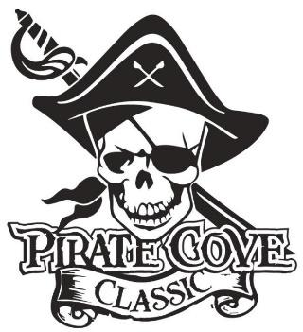
Program Advertising for Businesses

Deadline for submission is October 6, 2023

Name: _______________________________________________________________________

Company: ____________________________________________________________________

Address:______________________________________________________________________

Phone: _____________________________ E-mail: __________________________________

AD SIZE AD DIMENSIONS COST
Quarter Page | 4.25” x 5.50” Portrait | $40
Half Page | 8.5” x 5.50” Landscape | $75
Full Page | 8.5” x 11” Portrait | $125
Inside Front Cover | 8.5” x 11” Portrait | $200
Inside Back Cover | 8.5” x 11” Portrait | $200
Back Cover | 8.5” x 11” Portrait | $250
Inside Spread (2 full pages facing) | 8.5” x 11” Portrait x 2 | $500

Please email camera ready art to pccsponsors.ads@gmail.com
Preferred file formats: hi-res JPEG, PNG, or PDF files. Minimum of 300dpi.

If you need the ad to be created for you, please include a $10 fee.

Payment can be made online Porterridgeband.org. Under the menu, select Pirate Cove
Classic.

Payment can be made online www.Porterridgeband.org. Under the menu, select Pirate Cove Classic.

Other ways to pay:
Enclose completed form, payment, checks made out to PRBB, and place in the lock box in
the band room office or mail to:
Porter Ridge Band Boosters/PCC
P. O. Box 1624
Indian Trial, NC 28079

Questions? Please contact us at pccsponsors.ads@gmail.com Thank you for your support!

