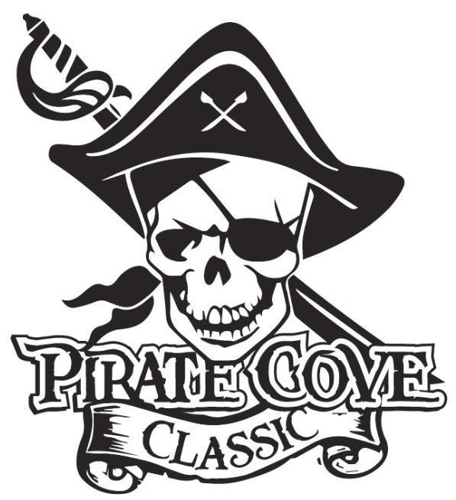
Pirate’s First Mate Ad
$25
Deadline for submission is October 6, 2023

A Pirate’s First Mate ad is your opportunity to share a special message with any band member. Ads are available to parents, grandparents, friends, or anyone who would like to send a message. Each ad is business card size.

Name of person you are recognizing:__________________________________________

Message: _______________________________________________________________

_______________________________________________________________________
_______________________________________________________________________
From: __________________________________________________________________

Payment can be made online www.Porterridgeband.org. Under the menu, select Pirate Cove Classic.

Please e-mail completed message form to piratecoveclassic@gmail.com or place everything in an envelope and place in the lock box in the band room office.

Other ways to pay:
Enclose completed form, payment, checks made out to PRBB, and place in the lock box in
the band room office or mail to:
Porter Ridge Band Boosters/PCC
P. O. Box 1624
Indian Trial, NC 28079

