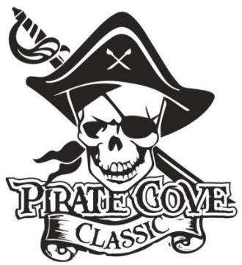
Class of 2022
Senior Ads

Name: _______________________________________________________________________

Address: _____________________________________________________________________

Phone: __________________________ E-mail: _____________________________________

Deadline for submission is October 13, 2021

QTY | Ad Size | Cost | Total
 | 1/4 page | $40
 | 1/2 Page | $60
 | Full Page | S100

The intention is for Senior Ads to be printed in color and spread throughout the program based on size of ads.
Please e-mail artwork and a copy of completed form to pccseniorads@gmail.com

Preferred file formats: hi-res JPEG, PDF files. *Ad Mock-Up must be print ready.

Payment can be made through PayPal on the PRBB website or enclose completed form, payment (checks made out to PRBB), and place in the lock box in the band room office.

No ads will be included or designed without payment verification!

Questions? Please contact us at pccseniorads@gmail.com

Thank you for your support!

