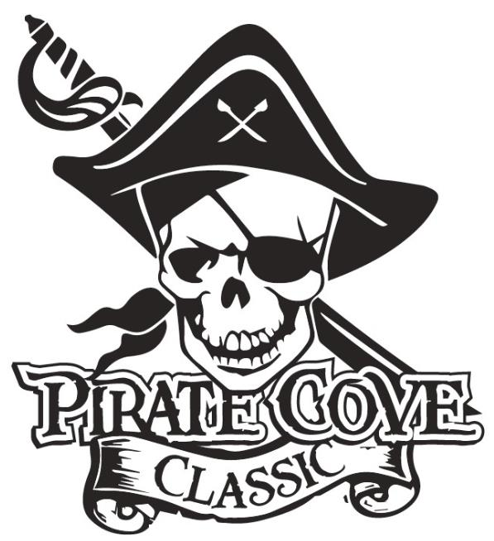
Trophy Sponsorship
Deadline for submission is October 19, 2021

$10
Number Needed per Class | Place | Number of Trophies Desired | Cost Per Trophy | Total $
7 | 1st Place |  | $35
7 | 2nd Place |  | $25
7 | 3rd Place |  | $20
1 Overall | Best Pit Crew |  | $35
1 Overall | Spirit Award |  | $35
3 Overall | Top Scoring |  | $50
Class  1A/2A/3A | Grand Champion |  | $250
Class  4A/5A/6A | Grand Champion |  | $250

All Trophy Sponsorships will be included in the competition program and announced at presentation.

Sponsor’s NAME and PHONE NUMBER: ___________________________________________________
______________________________________________________________________________________

Message: ______________________________________________________________________________
______________________________________________________________________________________
______________________________________________________________________________________
(Example: Sponsored by Joe’s Auto in honor of the Tommy Tuba.)

No Trophy Sponsorships will be recorded without payment and form.
Payment can be made online Porterridgeband.org. Under the menu, select Pirate Cove Classic.
Please email the completed sponsorship form to: pcctrophies@gmail.com.
Other ways to pay:
Enclose completed form, payment, checks made out to PRBB, and place in the lock box in the band room office or mail to:
Porter Ridge Band Boosters/PCC
P. O. Box 1624
Indian Trial, NC 28079
Questions? Please contact our co-chair at pcctrophies@gmail.com

