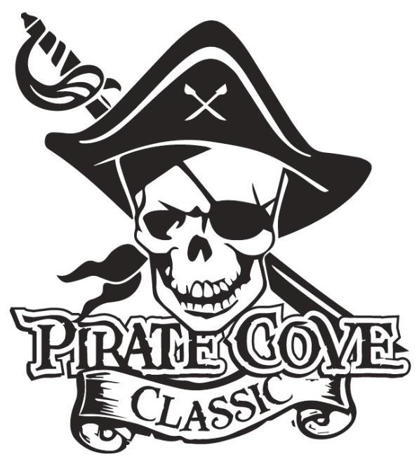
Pirate’s First Mate Ad
$15

$10

A Pirate’s First Mate ad is your opportunity to share a special message with any band member. Ads are available to parents, grandparents, friends, or anyone who would like to send a message. Each ad is business card size.

Please complete this form and return it with your payment. Please place everything in an envelope and put all envelopes in the lock box in the band room office.

Name of person you are honoring: ___________________________________________

Message: _______________________________________________________________

_______________________________________________________________________
_______________________________________________________________________
_______________________________________________________________________
From: __________________________________________________________________

Payment can be made online Porterridgeband.org. Under the menu, select Pirate Cove Classic.
Please e-mail completed message form to piratecoveclassic@gmail.com

Other ways to pay:
Enclose completed form, payment, checks made out to PRBB, and place in the lock box in
the band room office or mail to:
Porter Ridge Band Boosters/PCC
P. O. Box 1624
Indian Trial, NC 28079

**Deadline for submittals is October 10, 2021

