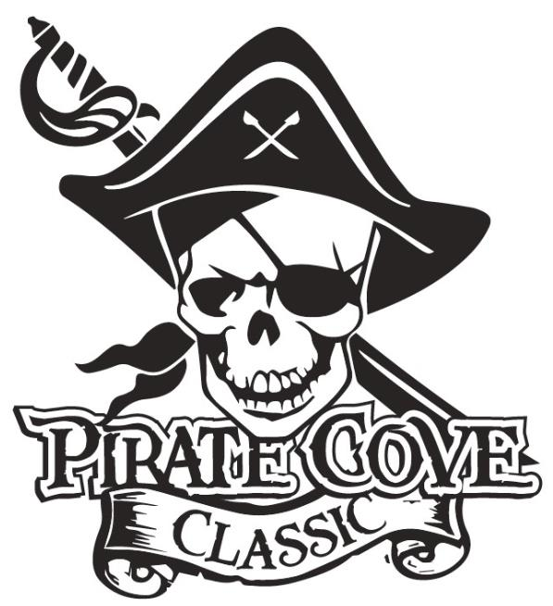
Corporate Sponsorship Levels

Swabbie $300
- Name in program as a sponsor
- Name on website

Mate $500
- Name in program as a sponsor
- Name on website
- Name listed on banner during event

Master Gunner $1000
- Name in program as a sponsor
- ¼ page ad in the program
- Name and logo on website
- Name and logo on banner

Quarter Master $1500
- Name in program as sponsor
- ¼ page ad in the program
- Name and logo on website
- Name and logo on banner
- Announcement on sponsorship during event awards

The Captain $2000
- Name in program as sponsor
- ½ page ad in the program
- Name and logo on website
- Name and logo on your own “Captain” Level Sponsor Banner
- Announcement on sponsorship throughout the event
- Sign on for future “Captain” levels for $1800 for upcoming years

NOTE: BANNER SIZES WILL BE NO LESS THAN 2’ X 2’ AND PLACED IN THE STADIUM DURING THE EVENT. SIZES WILL VARY DEPENDING ON NUMBER OF SPONSORS.
Porter Ridge Band Boosters is a recognized as a 501(c)(3) tax-exempt organization and all contributions are tax deductible.

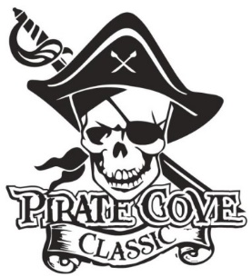
Corporate Sponsor
Order Form

$10

Name: _______________________________________________________________________

Address: _____________________________________________________________________

Phone: _____________________________ E-mail: __________________________________

Deadline for submission is October 10, 2019

Sponsorship Level | Cost | Total
Swabbie | $300
Mate | $500
Master Gunner | $1000
Quarter Master | $1500
The Captain | $2000

Please e-mail artwork and this form filled out to pccsponsors.ads@gmail.com@gmail.com
Preferred file formats: hi-res JPEG, PDF files.
See additional sheet for information on each level of sponsorship. “Captain” levels may supply their own banner as an option.
Enclose completed form, payment, checks made out to PRBB, and place in the lock box in the band room office or
mail to: Porter Ridge Band Boosters/PCC
P. O. Box 1624
Indian Trial, NC 28079

Questions? Please contact us at pccsponsors.ads@gmail.com

Thank you for your support!

