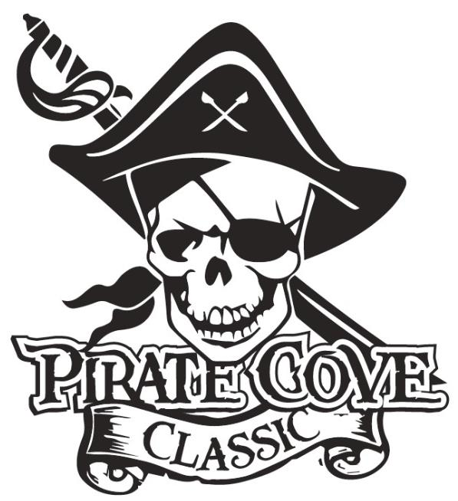
Corporate Sponsorship Levels
Deadline for submission is October 5, 2018

$10

Swabbie $300
- Name in program as a sponsor
- Name on website

Mate $500
- Name in program as a sponsor
- Name on website
- Name listed on banner during event

Master Gunner $1000
- Name in program as a sponsor
- ¼ page ad in the program
- Name and logo on website
- Name and logo on banner

Quarter Master $1500
- Name in program as sponsor
- ¼ page ad in the program
- Name and logo on website
- Name and logo on banner
- Announcement on sponsorship during event awards

The Captain $2000
- Name in program as sponsor
- ½ page ad in the program
- Name and logo on website
- Name and logo on your own “Captain” Level Sponsor Banner
- Announcement on sponsorship throughout the event
- Sign on for future “Captain” levels for $1800 for upcoming years

NOTE: BANNER SIZES WILL BE NO LESS THAN 2’ X 2’ AND PLACED IN THE STADIUM DURING THE EVENT. SIZES WILL VARY DEPENDING ON NUMBER OF SPONSORS.
Porter Ridge Band Boosters is a recognized as a 501(c)(3) tax-exempt organization and all contributions are tax deductible.

