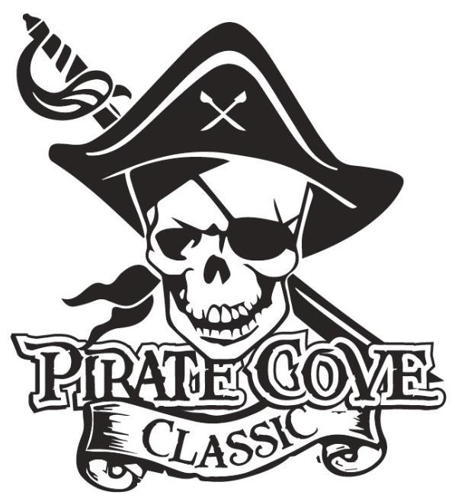
Pirate’s First Mate Ad
$10

$10

A Pirate’s First Mate ad is your opportunity to share a special message with any band member. Ads are available to parents, grandparents, friends, or anyone who would like to send a message. Each ad is business card size.

Please complete this form and return it with your payment. Please place everything in an envelope and put all envelopes in the lock box in the band room office.

Name of person you are honoring: ___________________________________________

Message: _______________________________________________________________

_______________________________________________________________________
_______________________________________________________________________
_______________________________________________________________________
From: __________________________________________________________________

*Ad content may be emailed to piratecoveclassic@gmail.com

(Please make checks payable to PRBB)

**Deadline for submittals is October 5, 2018

