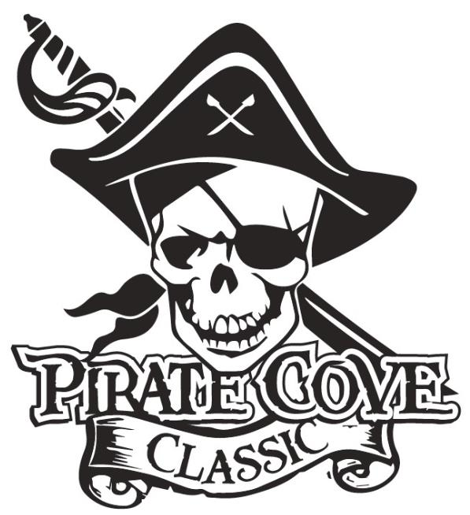
Trophy Sponsorship
Deadline for submission is October 10, 2019

$10

Number Needed per Class | Place | Number of Trophies Desired | Cost Per Trophy | Total $
7 | 1st Place |  | $35
7 | 2nd Place |  | $25
7 | 3rd Place |  | $20
1 Overall | Best Pit Crew |  | $35
1 Overall | Spirit Award |  | $35
3 Overall | Top Scoring |  | $50
Class  1A/2A/3A | Grand Champion |  | $250
Class  4A/5A/6A | Grand Champion |  | $250

All Trophy Sponsorships will be included in the competition program and announced at presentation.

Sponsor’s NAME and PHONE NUMBER: ___________________________________________________
______________________________________________________________________________________

Message: ______________________________________________________________________________
______________________________________________________________________________________
______________________________________________________________________________________
(Example: Sponsored by Joe’s Auto in honor of the Tommy Tuba.)

No Trophy Sponsorships will be recorded without payment and form, please email a copy of this form to pcctrophies@gmail.com
Mail payment, checks made out to PRBB, and this sponsorship form or place in lock box in the band room office: Porter Ridge Band Boosters/PCC
P. O Box 1624
Indian Trail, NC 28079
Questions? Please contact our co-chair at pcctrophies@gmail.com
Thank you for your support!

