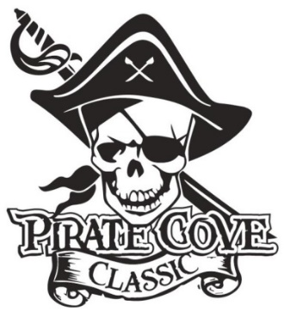
Class of 2020
Senior Ads

$10

Name: _______________________________________________________________________

Address: _____________________________________________________________________

Phone: _____________________________ E-mail: ___________________________________

Deadline for submission is October 10, 2019
*Deadline for submission that includes Design Assistance is September 27, 2019*

QTY | Ad Size | Cost | Total
 | 1/4 page | $35
 | *Design Assistance Fee | $10
 | 1/2 Page | $60
 | *Design Assistance Fee | $10
 | Full Page | S100
 | *Design Assistance Fee | $10

The intention is for Senior Ads to be printed in color and spread throughout the program based on size of ads.
Please e-mail artwork and a copy of completed form to pccseniorads@gmail.com

Preferred file formats: hi-res JPEG, PDF files. *Ad Mock-Up must be print ready. Design Assistance is available, for an additional $10 fee. *

Enclose completed form, payment (checks made out to PRBB), and place in the lock box in the band room office, or mail to: Porter Ridge Band Boosters/PCC
P. O. Box 1624
Indian Trial, NC 28079

No ads will be included or designed without payment verification!

Questions? Please contact us at pccseniorads@gmail.com

Thank you for your support!

