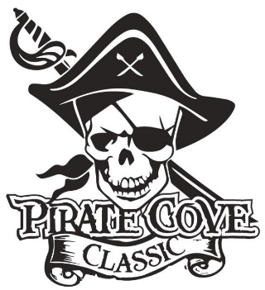
Program Advertising
Business and First Mate Ads

$10

Business Advertising
Name: _______________________________________________________________________

Company: ____________________________________________________________________

Address:______________________________________________________________________

Phone: _____________________________ E-mail: __________________________________

Deadline for submission is October 7, 2019

QTY | Ad Size | Cost | Total
 | Business Card | $25
 | 1/4 Page | $35
 | 1/2 Page | $65
 | Full Page | $100
 | Full Color Back Cover | $200

Please e-mail copy of form and artwork to pccsponsors.ads@gmail.com Preferred file formats: hi-res JPEG, PDF files.

Enclose completed, payment, checks made out to PRBB, and mail to:
Porter Ridge Band Boosters/PCC
P. O. Box 1624
Indian Trial, NC 28079
Or place in the lock box in the band room office.

Questions? contact us at pccsponsors.ads@gmail.com

Thank you for your support!

First Mate Ads
A Pirate’s First Mate ad is an opportunity for family and friends to share a special message with any band member. Each ad is business card size.

Complete this form and return it with payment to the lock box located in the band room office. OR mail to Porter Ridge Band Boosters/PCC
P. O. Box 1624
Indian Trial, NC 28079

Make checks payable to PRBB.

Deadline for submittals is October 10, 2019

Ad content may be emailed to pccsponsors.ads@gmail.com Please note, no verbal submissions will be recognized. All paperwork must be submitted and payment verified before inclusion in the program.

Name of person you are honoring: _________________________________________________________

Message: _____________________________________________________________________________

_____________________________________________________________________________________
_____________________________________________________________________________________
_____________________________________________________________________________________
From: _______________________________________________________________________________
In case there are questions please provide the following -
Purchaser Name: _________________________________________ Phone: _______________________
Email: _______________________________________________________________________________

Questions? Contact us at pccsponsors.ads@gmail.com

Thank you for your support!

