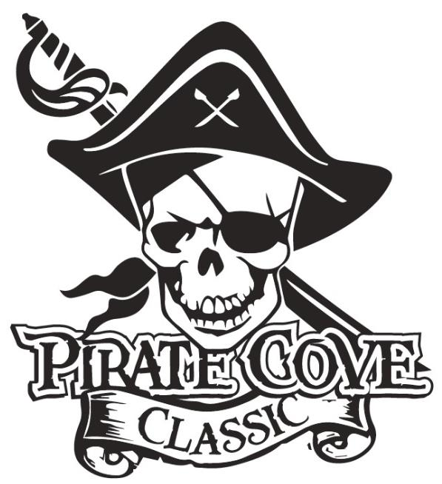
Trophy Sponsorship
Deadline for submission is October 5, 2018

$10

Please circle your selections for class & trophy category.
Class  (Circle Choice) | Place | Trophy Category  (Circle Choice) | Cost Per Trophy | Total $
1A, 2A, 3A, 4A, 5A or 6A | 1st Place | Band / Music / Marching / General Effect /  Drum Major / Percussion / or Color Guard | $35
1A, 2A, 3A, 4A, 5A or 6A | 2nd Place | Band / Music / Marching / General Effect /  Drum Major / Percussion / or Color Guard | $25
1A, 2A, 3A, 4A, 5A or 6A | 3rd Place | Band / Music / Marching / General Effect /  Drum Major / Percussion / or Color Guard | $20
Overall |  | Best Pit Crew | $35
 | Top Scoring | Drum Major / Percussion / or Color Guard | $50
 |  | GRAND CHAMPIONS
Class  1A/2A/3A | Grand Champion |  | $250
Class  4A/5A/6A | Grand Champion |  | $250

All Trophy Sponsorships will be included in the competition program and announced at presentation.

Deadline for submission and payment is October 5, 2018 (NO EXCEPTIONS)

Sponsor’s NAME and PHONE NUMBER: ___________________________________________________

Message: ______________________________________________________________________________
(Example: Sponsored by Joe’s Auto in honor of the Tommy Tuba.)

Enclose payment and completed sponsorship form for your trophy in an envelope and mail to:
Porter Ridge Band Boosters/PCC
P. O Box 1624
Indian Trail, NC 28079 OR

Place in the lock box in the band room office.
Questions? Please contact Renee Hastings or Linda Robinson at piratecoveclassic@gmail.com

