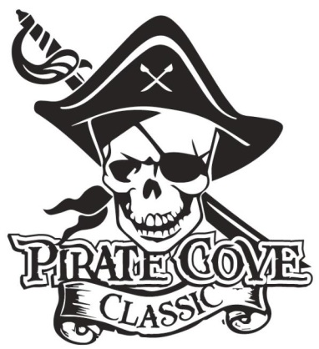
Class of 2019
Senior Ads

$10

Name: _______________________________________________________________________

Address:______________________________________________________________________

Phone: _____________________________ E-mail: __________________________________

Deadline for submission is October 5, 2018
*Deadline for submission that includes Design Assistance is September 15, 2018*

QTY | Ad Size | Cost | Total
 | 1/4 page | $35
 | *Design Assistance Fee | $10
 | 1/2 Page | $60
 | *Design Assistance Fee | $10
 | Full Page | S100
 | *Design Assistance Fee | $10

The intention is for Senior Ads to be printed in color and spread throughout the program based on size of ads.
Please attach camera ready art or e-mail artwork to piratecoveclassic@gmail.com
Preferred file formats: hi-res JPEG, PDF files. *Ad Mock-Up must be print ready. Design Assistance is available, for an additional $10 fee. *

Enclose completed form and payment in an envelope in the lock box in the band room office, or
mail to: Porter Ridge Band Boosters/PCC
P. O. Box 1624
Indian Trial, NC 28079

Questions? Please contact Renee Hastings or Linda Robinson at piratecoveclassic@gmail.com

